HOSTEL MANAGEMENT SYSTEM
@CREATIVITY THINK (9483175986/7019689991)

ABSTRACT:
The Hostel Management System is a web-based solution designed to streamline hostel operations through automated room allocation, mess payment tracking, notice board updates, and student attendance monitoring. Users can check in or out, select rooms, access mess fee information, and receive important updates, while administrators manage room assignments, payments, student records, and analytics. Built using Django and Django Rest Framework on the backend and React with Redux and Chart.js on the frontend, the system ensures efficient handling of hostel workflows. This platform enhances transparency, reduces manual workload, and improves communication for institutions managing hostels or dormitories..

INTRODUCTION OF THE PROJECT:
Hostels and paying guest accommodations often face operational challenges such as manual room allocation, mess fee tracking, communication gaps, and inconsistent attendance monitoring. The Hostel Management System addresses these issues by providing a centralized digital platform for both students and administrators. Students can view their room details, mess fee records, and notifications, while admins efficiently manage student records, room availability, payments, and reports. Utilizing Django for backend logic and React with Redux for an interactive frontend, the system ensures accurate, real-time hostel operations management that supports institutions, PGs, and dormitory environments..

PROJECT OBJECTIVES:

• To develop a digital platform for managing hostel rooms and students
• To automate room allocation and assist with real-time availability tracking
• To provide mess fee tracking and payment management
• To allow users to receive notices, updates, and attendance information
• To equip administrators with dashboards for analytics and reporting
• To enhance operational efficiency and reduce manual administrative workload

PROBLEM OF THE STATEMENT:
Traditional hostel management involves heavy paperwork, manual tracking of room availability, mess payments, and communication, leading to frequent errors and inefficiencies. Students often lack transparency in room details, attendance records, and fee status. Administrators struggle with maintaining accurate student logs, payment histories, and mess lists. The Hostel Management System solves these challenges by offering a centralized web application where students and staff interact through real-time digital tools, enabling precise tracking, improved communication, and automated hostel operations..

MOTIVATION OF THE PROJECT:
• Reduce manual errors in hostel room and mess management
• Improve communication between hostel staff and students
• Provide a clear overview of payments, attendance, and notices
• Streamline administrative tasks with digital automation
• Enhance transparency and accountability across hostel operations

BLOCK DAIGRAM OF PROJECT:

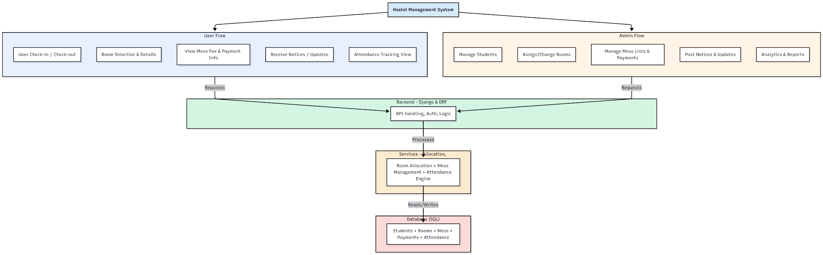

WORKING OF THE PROJECT:
The Hostel Management System operates by allowing students to check in or check out digitally, select rooms based on availability, and access mess fee information and notices on their dashboard. Attendance records and updates are viewable in real time. The backend manages authentication, fee tracking, attendance logic, and messaging, while services handle room allocation, payments, and mess tracking. Administrators use their dashboard to manage students, allocate rooms, record payments, manage mess lists, post notices, and generate analytics reports. Together, these workflows create a seamless, transparent hostel management experience for institutions and students..

SOFTWARE REQUIREMENT:
- Backend:
  - Python 3.x
  - Django
  - Django REST Framework
  - SQLite/PostgreSQL
- Frontend:
  - Node.js and npm
  - React.js
  - Axios
- Development Tools:
  - Visual Studio Code
  - Postman (for testing APIs)
  - Git/GitHub (for version control)
- Server/Deployment (Optional):
  - Gunicorn, Nginx, or Heroku/AWS for hosting

ADVANTAGES OF THE PROJECT:

• Automates room allocation and reduces manual errors
• Provides digital tracking of mess payments and attendance
• Offers instant communication via notices and updates
• Gives admins powerful dashboards and analytics
• Enhances user experience through transparency and accessibility
• Reduces administrative workload and improves accuracy
• Supports real-time hostel operations and reporting
• Suitable for various hostel and PG environments

APPLICATIONS OF THE PROJECT:
• College and university hostels
• PG accommodations
• Private dormitories
• Staff quarters and institutional housing
• School residential facilities
• Training centers with accommodation
• Corporate dorms
• Government or military hostel facilities

REFERENCES:

- Django REST Framework Documentation — Django Software Foundation. Django Documentation. Available: https://docs.djangoproject.com/
- Django REST Framework. DRF Documentation. Available: https://www.django-rest-framework.org/
- React. React Official Documentation. Available: https://reactjs.org/docs/getting-started.html
- Redux. Redux Documentation. Available: https://redux.js.org/introduction/getting-started
- PostgreSQL Global Development Group. PostgreSQL Documentation. Available: https://www.postgresql.org/docs/
- MySQL. MySQL Reference Manual. Available: https://dev.mysql.com/doc/
- Git. Git Documentation. Available: https://git-scm.com/doc
- Node.js. Node.js Documentation. Available: https://nodejs.org/en/docs/
- Axios. Axios Documentation. Available: https://axios-http.com/docs/intro
- Socket.io Documentation – https://socket.io/docs/

